**DAILY ONLINE ACTIVITIES SUMMARY**

|  |  |  |  |  |  |  |  |  |
| --- | --- | --- | --- | --- | --- | --- | --- | --- |
| **Date:** | **03/06/2020** | | | | | **Name:** | **SHREEKIRAN R BHAT** | |
| **Sem & Sec** | **IV sem & B section** | | | | | **USN:** | **4AL18CS080** | |
| **Online Test Summary** | | | | | | | | |
| **Subject** | | **Object Oriented Concepts** | | | | | | |
| **Max. Marks** | | **30** | | **Score** | | | **18** | |
| **Certification Course Summary** | | | | | | | | |
| **Course** | **Cloud Foundations** | | | | | | | |
| **Certificate Provider** | | | **Greatlearning academy** | | **Duration** | | | **4.5 hours** |
| **Coding Challenges** | | | | | | | | |
| **Problem Statement1:** Write a Java program to find Last Digit of a^b (a to the power b) for Large Numbers.  **Problem Statement2:** Write a code segment in java to swap two numbers using call by object reference.  **Problem Statement3:**Write a function that takes a two-digit number and determines if it's the largest of two possible digit swaps. | | | | | | | | |
| **Status: Executed** | | | | | | | | |
| **Uploaded the report in Github** | | | | | **YES** | | | |
| **If yes Repository name** | | | | | **Online-coding** | | | |
| **Uploaded the report in slack** | | | | | **YES** | | | |

Online Test Summary: 18CS45 test was scheduled from 9:30 am t0 10:00am .The portion for the IA was 2nd and 3rd module there were 30 questions and the time assigned was 45 minutes the questions were to predict the output of the given program.

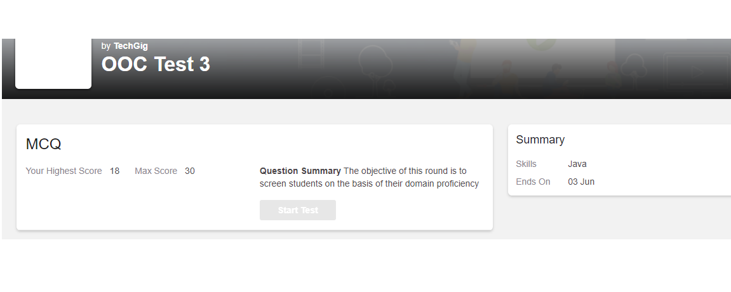

The above snap shot is the completion of the test and the marks allotted.

Online Certification Course Summary: In today’s session I have learnt about Price Economics, Data Velocity and Distributed Computing and also about Apps for cloud and security model and last I learnt what is Infra.Automation, Abstraction, Provisioning and Allied Tech. with this I have successfully completed the course by attending the quiz.

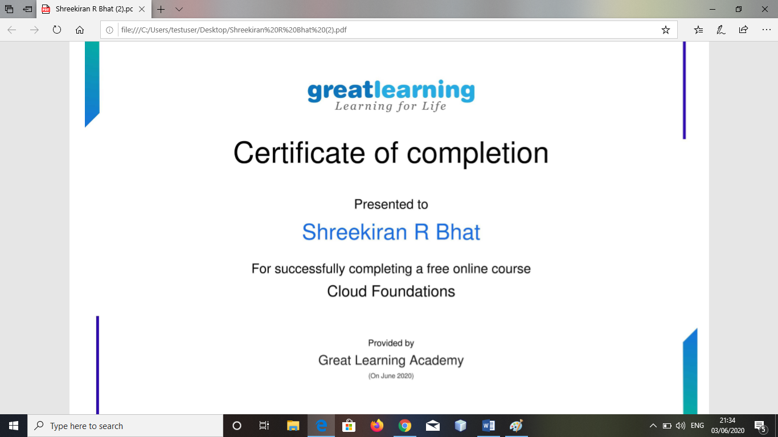

This is the certificate of completion of the course .

Online Coding Summary: **Today I had received one program from prof. Shilpa CSE Dept. the other from Prof. Reena Lobo CSE Dept. and Prof.Vasudev CSE Dept. The program is mentioned above in the coding challenges(pg.01). I have also uploaded it to my Github repository.**

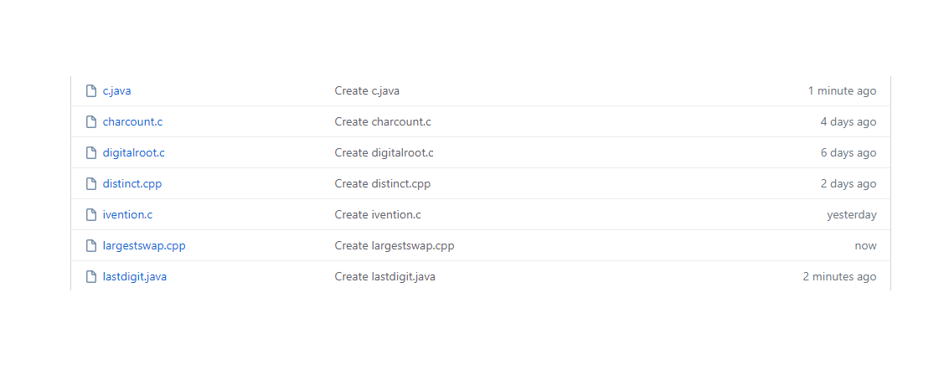

**This is the snap shot of my Github repository** were I have uploaded the code. File name is C.java, Lastdigit.java and Largestswap.cpp